CITY OF COFFEE CITY
SPECIAL COUNCIL MEETING AGENDA
MINUTES
7019 Pleasant Ridge Rd. Coffee City, Texas 75763 JUNE 29, 2021

NOTICE IS HEREBY GIVEN OF A MEETING OF THE CITY COUNCIL OF COFFEE CITY. TO BE HELD ON Tuesday, June 29, 2021, at 4 PM. AT THE COFFEE CITY, CITY HALL, 7019 PLEASANT RIDGE ROAD, COFFEE CITY, TEXAS. FOR THE PURPOSE OF CONSIDERATION OF THE FOLLOWING AGENDA ITEMS. THE CITY COUNCIL RESERVES THE RIGHT TO MEET IN A CLOSED SESSION ON ANY AGENDA ITEM SHOULD THE NEED ARISE AND APPLICABLE PURSUANT TO AUTHORIZATION BY TITLE 5, CHAPTER 551, OF THE TEXAS GOVERNMENT CODE.

- Council Members

Frank Serrato - Mayor Chuck Jones Place 1
Kevin Swanson Place 3
Riley Standifer - Mayor Pro Tern Marquis Castleberry Place 2
Ray Ver Hey Place 5

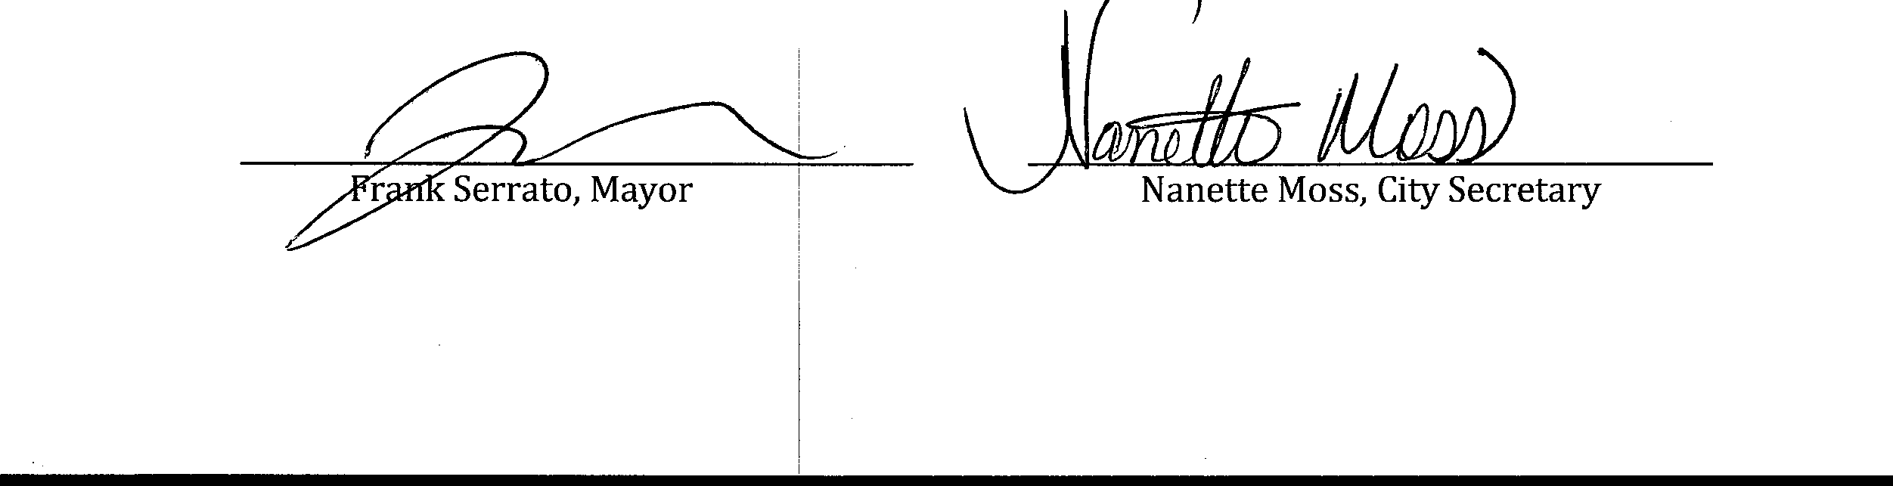
THE ITEMS LISTED BELOW ARE PLACED ON THE AGENDA FOR DISCUSSION AND/OR ACTION.

- Call to Order. Mayor Serrato called the meeting to order @ 4PM.

- Roll Call and announce if quorum is present: City Secretary called roll, Mayor Serrato (P) Councilman, Castleberry (P) Councilman, Swanson (P) Councilman, Jones (A) Councilman, Ver Hey (A) Mayor Pro Tem, Standifer (A). No quorum at the time of roll call. Mayor suggested that they wait 10 minutes to see if any other councilmen could make the meeting.

At 4:10PM. Roll call was taken again, the above where present no other Councilmen showed up. It was determined no Quorum could be formed. Meeting was canceled.
Mayor Serrato suggested that the Council re-schedule the Special Called meeting for Friday July 2, 2021 @ 4PM.

- Consider and Act upon Approving the FY 2021/2022 Budget

- Discuss Re-Appointment of the Coffee City Fire Chief, Chris Moore

- Consider and Act upon: TX DOT Resolution Road Construction Speed Limit.
The City Council of the City of Coffee City reserves the right to adjourn into Executive Session at any time during the course of this meeting to discuss any matters listed on the agenda, as authorized by the Texas Government Code, including, but not limited to, Sections 551.071 (Consultation with Attorney), 551.072 (Deliberation about Real Property), 551,073 (Deliberations about Gifts and Donations), 551.074 (Personnel Matters),
551.076 (Deliberation about Security Devices), 551.087 (Economic Development), 418.175-183 (Deliberations about Homeland Security Issues) and as authorized by the Texas Tax Code, including, but not limited to, Section 321.3022 (Sales Tax Information).

CERTIFICATION

I CERTIFY THAT A COPY OF THE TUESDAY JUNE :29, 2021, SPECIAL CITY COUNCIL MEETING AGENDA OF ITEMS FOR CONSIDERATION BY THE COFFEE CITY, CITY COUNCIL POSTED ON THE CITY HALL FRONT WINDOW AND CITY WEBSITE ON FRIDAY) June 25, 2021.

