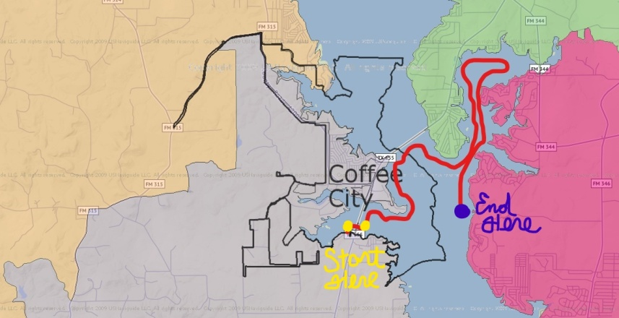
SATURDAY, DECEMBER 18TH, 2021
5:00 P.M.-7:00 P.M.

For more information contact:
Mark Bartlett
via email at
903mrb@gmail.com

Lake Palestine Boat Parade
Waiver of Liability

In consideration for acceptance of our entry in the Lake Palestine Boat Parade on December 18, 2021 at 5:00 p.m. I/we, the undersigned, hereby assume fully all risks incidental to the boat parade event and agree to hold harmless the organizer, Mark Bartlett; the sponsors, Coffee City EDC, Lake Palestine Resort, Bella Vista, Kilo’s, Lake Palestine Yacht Club and their officers, directors, agents and committee persons from all liabilities for any damages to myself or my guests, including any indirect, consequential, or incidental damages or injuries related to the parade. I/we am responsible for any legal actions or claims for damages or injuries relating to my participation in the parade. I/we, the undersigned agree to comply with all pertinent regulations, both governmental or Texas Parks and Wildlife.

Signed:_____________________________ Date: __________________

Printed Name: ______________________________________________

Contact info: Phone: _________________ Email: ___________________

